SPRINT – 1

|  |  |
| --- | --- |
| **Team ID** | **PNT2022TMID29786** |
| **Project Name** | **Project - SMART FASHION RECOMMENDER APPLICATION** |

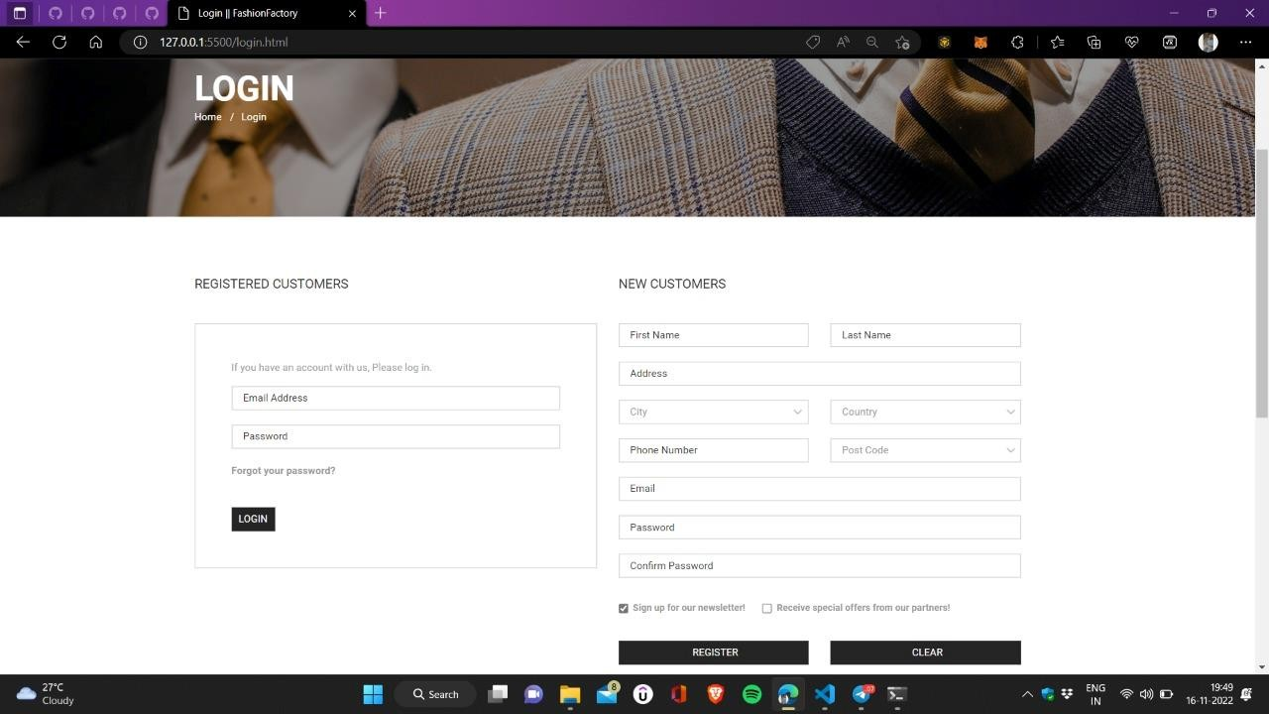 LOGIN PAGE / REGISTRATION PAGE:

PRODUCT PAGE:

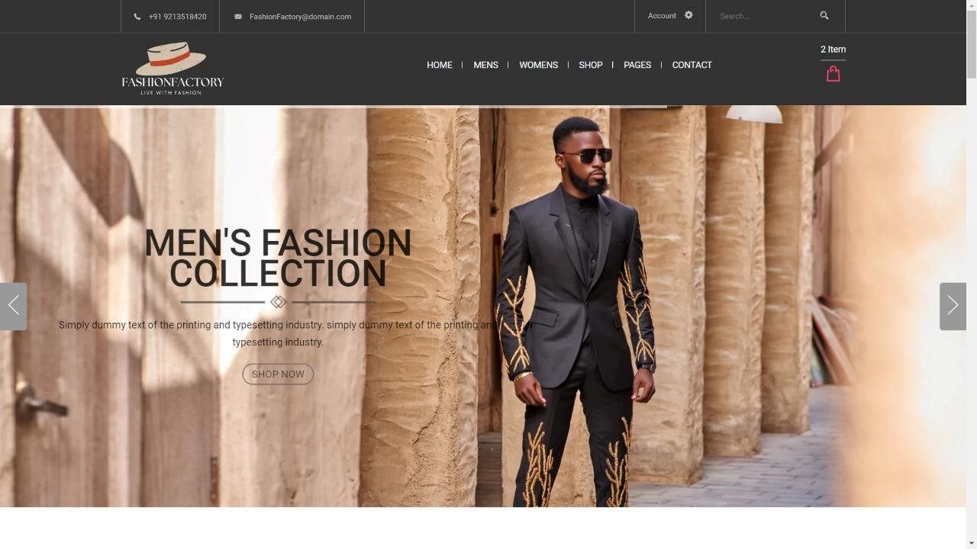

VIEW PRODUCT PAGE:

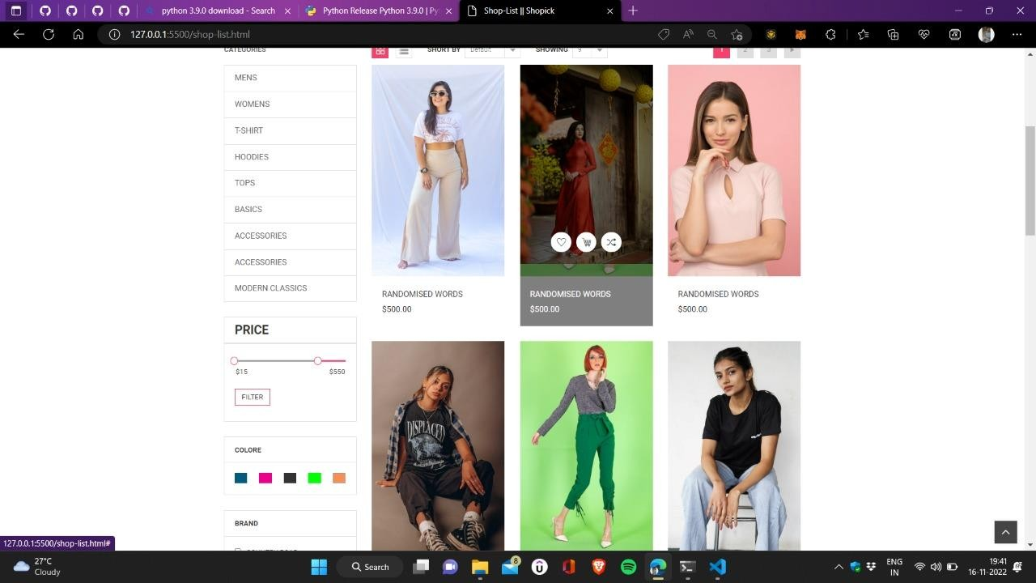

DATABASE: